软件需求工程
实验指导书

西北工业大学软件与微电子学院

第一部分 软件需求工程实验计划及总目标
课程名称：软件需求工程(Software Requirements Engineering)；
实验总学时： 16 学时（4*4）；
适用专业：软件工程；
先修课程：面向对象程序设计、软件工程概论。
一、实验计划及总目标
软件需求工程实验是《软件需求工程》课程中一项重要的实践环节，其目的在于贯彻以理论指导实际的教学原则，通过实验帮助学生在理解软件需求工程的过程、方法、工具的基础上，学习掌握实际软件项目中的需求分析和需求管理，从而提高学生运用CASE工具进行软件需求分析和管理的能力。
软件需求工程实验的任务主要有四项：（1）让学生掌握应用软件分析、设计和实现的基本过程；（2）帮助学生掌握应用软件工程的分析、设计、实现的方法；（3）让学生了解应用软件系统开发的一般过程；（4）让学生学习使用CASE工具。
上述任务的完成和实现，可使学生对所学专业有比较全面概括性的了解，激发学生的创新思维，正确认识软件开发的步骤和环节，为后续课程的学习以及就业打下坚实基础。
二、实验环境
PC机、Windows操作系统、UML、Rose、Rational等工具软件。
三、实验方式与基本要求
- 实验方式：指导教师先介绍实验内容和实验中的注意事项，然后学生根据课堂讲授知识分析实验题目、熟悉相关内容、搭建环境、完成实验内容、编写、完成实验报告。
- 基本要求：
包括UML建模、需求获取、需求分析、需求文档、需求管理等几个部分，要求学生根据实际项目的要求，应用传统的结构化方法或者面向对象方法进行需求分析。推荐使用UML和Rational Rose对需求进行分析；根据实际项目的要求，应用项目管理的一般方法或者需求管理的专用方法，对实际系统的需求进行管理；推荐使用Rational RequsitePro工具进行需求管理。
- 实验报告基本要求
实验报告内容的完整性。实验报告内容包括实验目的、实验内容、实验程序、实验结果、实验总结（通过实验学到了什么、遇到的出错及修改过程等）。书写规范、工整。
四、实验项目及教学安排
序号 | 实验项目 | 学时 | 实验内容和基本要求 | 实验类型 | 备注
1 | 需求获取与用例建模 | 4 | 假设你作为一个新的项目的负责人，你需要通过“问题描述”来定义系统的需求，要为需求定义一个用例模型。要确定参与者和用例，并开发出用例图。 | 设计型
2 | 需求分析 | 4 | 通过RU 金融信息案例分析，使用特定的分析方法（鱼骨图等）来查找问题发生的根源。你作为RU e-st项目的负责人，要证实股票交易系统是解决商业问题和帮助实现商业目标的最好的解决方案。带领你的团队通过问题分析来找到问题发生的根源。 | 综合型
3 | 需求文档 | 4 | 检查在线股票交易系统的需求规格说明，存在哪些不足，会导致开发者和用户的误解？查找、标记和记录可能的需求，确认新的参与者，并结合需求分析给出改进的需求规格说明书。 | 综合型
4 | 需求管理 | 4 | 作为项目负责人，你要负责项目的文档版本信息。你的团队要描述问题，确定股东和用户以及他们的需求，确定关键的产品特征等。给出职位描述，并确定和给出用例图。 | 设计型
5 | 综合实验项目（包括从需求到设计到实现） | 课外 | 运用IBM Rational等软件完成一个团队项目，每个团队4-6个学生组成，涉及需求开发过程和需求管理过程，包括完成以下任务：  定义项目的业务需求、项目视图及涉及的范围；客户分析、客户交流与需求获取；定义与需求相关的项目风险需求分析；撰写需求规格说明；需求质量验证；需求评审；需求变更管理和跟踪；需求管理工具的使用 | 综合型 | 分组完成

五、考核方式及成绩评定
- 考核以实验平时考核和实验报告相结合的方式进行。
- 实验成绩评定方法：学生实验成绩的评定都必须按照实验的要求，以实际实验能力的强弱作为主要依据。
六、实验教材、参考书：
教材：
软件需求工程(软件工程系列规划教材), 康雁等, 科学出版社, 2014
实验参考书：
学生实验内容_IBM需求开发与管理实验.pdf
其他参考书：
需求工程——软件建模与分析,骆斌、丁二玉,高等教育出版社, 2015 年2月
软件需求工程原理和方法, 金芝 编, 科学出版社, 2010年2月
需求工程-基础、原理和技术, [德] Klaus Pohl 编；彭鑫 等 译,机械工业出版社,2012年
软件需求管理用例方法(第2版)，（美）莱芬韦尔 等著，蒋慧译，中国电力出版社，2004年05月。

第二部分 实验部分

实验一 需求获取与UML建模
1.实验目的
- 了解需求开发阶段在业务领域对系统建模的重要性；
- 掌握获取和确立业务需求的技术和方法；
- 掌握业务需求建模的模型表示法和相应的文档编写方法；
2.预习与实验要求
- 预习实验指导书及教材的有关内容，了解业务需求的概念及重要性；
- 掌握获取和分析业务需求的方法；
- 实验前认真听讲，服从安排，尽可能独立思考并完成实验。
3.实验原理
- 通过业务需求定义产品前景；
- 业务需求与用例；
- 业务需求在前景与范围文档中的地位；
- 业务需求获取与建模的方法；
4.实验内容 ：
1 确定参与者和用例
本实验的目的在于，在一个虚拟的项目中确定参与者和用例。你将参与到在线课程注册系统的案例并进行案例分析，首先确定系统的参与者，“学生“是一个确定的参与者，在该系统中与哪些成员进行互动呢？对于每一个参与者，请确定其与系统进行交互的类型，其中包括确定用例和为用例命名的规则等。完成下列工作：
- 确定与系统交互的参与者
- 确定用例
- 画出系统的用例图
You have just been assigned the job of lead system analyst for a new system. You have been given a problem description (“Initial System Requests” below). Your first task is to understand the requirements for the new system. From the Initial Requests, you develop a use-case model of the requirements. In this first part of the modeling process, you identify actors and use cases and develop a use-case diagram. As you look at the initial requests for the system, note that the requirements are far from complete. Note what assumptions you make, as well as what other information you want to ask your customer.
Directions:
1. Read the Initial System Requests document.
2. Draw the use-case diagram on easel paper or the board.
• Show actors, use cases, and communicates-associations.
3. Compare the diagram with the sample solution.
4. Discuss the “Discussion Topics” at the end of this exercise.
Wylie College is planning to develop a new online Course Registration System. The new Web-enabled system replaces its much older system developed around mainframe technology. The new system allows students to register for courses from any Internet browser. Professors use the system to register to teach courses and torecord grades.
Because of a decrease in federal funding, the college cannot afford to replace the entire system at once. The college will keep the existing course catalog database where all course information is maintained. This database is an Ingres relational database running on a DEC VAX. The legacy system performance is poor, so the new system accesses course information from the legacy database but does not update it. The registrar’s office continues to maintain course information through another system. Students can request a printed course catalog containing a list of course offerings for the semester. Students can also obtain the course information online at any time. Information about each course, such as professor, department, credit hours, and prerequisites assists students in making informed decisions. The new system allows students to select four course offerings for the coming semester. In addition, each student indicates two alternate choices in case the student cannot be assigned to a primary selection. Courses have a maximum of ten and a minimum of three students.
The registration process closes on the first or second day of classes for the semester. Any course with fewer than three students enrolled on the day registration closes is cancelled. All courses without an instructor on the day registration closes are cancelled. Students enrolled in cancelled classes are notified that the course has been cancelled, and the course is removed from their schedules. The registration system sends information about all student enrollments to the Billing System so that the students can be billed for the semester. For the first two weeks of the semester, students are allowed to alter their course schedules. Students may access the online system during this time to add or drop courses. Changes in schedules are immediately sent to the Billing System so that an updated bill can be sent to the student. At the end of the semester, the student can access the system to view an electronic report card. Since student grades are sensitive information, the system must employ security measures to prevent unauthorized access. All students, professors, and administrators have their own identification codes and passwords. Professors must be able to access the online system to indicate which courses they want to teach. They also need to see which students signed up for their course offerings. In addition, professors can record the grades for the students in each class.
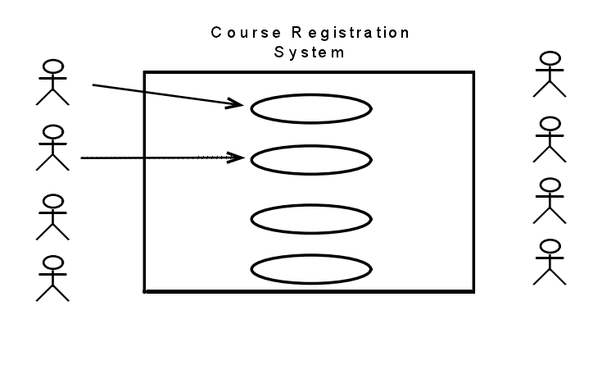
1.确定参与者。（谁使用该系统？谁从系统中获取信息？谁为系统提供信息？谁来维护该系统？还有哪些系统会用到该系统？）
2确定用例。（.每个参与者使用该系统的目的是？各个参与者会创建、存储、修改、或者读取系统中的数据吗？参与者需要告诉系统外部的时间或者更改吗？参与者需要告诉系统突发时间吗？这个系统能够提供所有的正确事件吗？）
5.实验报告
- 详细描述实验的过程和步骤；
- 详细填写完成实验的收获和得失，实验过程中遇到的问题、解决的办法、实验心得以及对该实验的建议和意见。

实验二 需求分析
1.实验目的：
- 掌握需求开发阶段需求的获取和分析的技术和方法；
- 掌握对获取和分析的需求进行建模的方法，掌握建模的基本图形表示法；
- 能把需求获取和分析方法运用到实际的系统分析中，并能运用建模工具和模型记录结果；
2.预习要求：
- 预习实验指导书及教材的有关内容，掌握软件需求基本概念，能运用需求获取和分析的技术和方法对实际的系统进行分析；
- 掌握需求分析的建模方法，熟悉建模工具；
- 运用建模工具和需求获取分析方法对实际系统进行分析，并记录结果；
- 实验前认真听讲，服从安排。尽可能独立思考并完成实验。
3.实验内容：
- 熟悉和掌握UML和Rational Rose工具的使用。在rose中创建新的模型，分别画出如下的图：用例图、类图、包图、活动图、顺序图、状态图等。
- RU 金融信息系统案例
练习4.1 本练习中，首先请熟悉RU金融信息系统，该案例在本课程中作为一个提供需求分析和管理的经典案例。实验的目的在于应用需求分析技术，确定在项目领域中可能出现的隐藏的问题，因为不是每一个问题都能够在一开始就表现的很明显。
目标：熟悉RU金融信息系统项目的细节。
学习如何通过问题分析技术来寻找一个问题产生的根源。
通过RU 金融信息案例分析，使用特定的分析方法（鱼骨图等）来查找问题发生的根源。假设你作为RU e-st项目的负责人，要证实股票交易系统是解决商业问题和帮助实现商业目标的最好的解决方案。带领你的团队通过问题分析来找到问题发生的根源。
方法：通过鱼骨图的方法来确定问题发生的根源。
        - 使用鱼骨图进行问题分析。
        - 确定该问题的最大可能的导致因素。
        - 讨论所提出的方案是不是真正的最优方案。
        - 将你的解决方案与示例方案进行比较。
Business Problem:
RU Financial Services is an investment management organization with 500 offices located across every state. The head office is located in the nation’s capital. RU Financial Services was the first to market with online stock trading in 1992. The personal stock trading business exceeded all expectations and became a significant part of RU Financial Services’ revenue for the next eight years. Since then the company has had difficulty attracting new customers to their service, and existing customers have been switching to rival companies at an alarming rate.
The goal is to see how RU Financial Services can regain its market share and continue to grow the personal stock trading side of the business. The board members have done some analysis and decided that the current stock trading system needs replacing. Harold Smedley, the Vice-President of RU Financial Services, has asked you to determine if this truly is the best course of action.
• Based on a recent customer satisfaction survey, 60% of customers were not satisfied with how long it took for updates to the software to become available. This dissatisfaction figure needs to be reduced to less than 5%.
• The current business model for RU Financial Services mandates that infrastructure costs should not be more than 10% of the revenue generated by the business. This is currently running at 40%.
• Maintenance costs of the software are currently running at 25% above the average maintenance costs of other software in the company. This figure must be reduced to no more than 15%.
• Based on a recent survey, it was found that 70% of customers require additional services that the current system does not provide. The main requests were: real- time stock quotes; ability to research stock, ability to fund trading account directly from a savings account held in another financial institution, and Web access instead of having to install client software.
• About 2% of customers have experienced errors in their trades in the last six months. This figure must be reduced to 0%.
The Business Background:
RU Financial Services introduced their online trading system in 1992 before the birth of e-commerce. At that time, the company had a corporate standard architecture of VAX 6300 mainframe computers and DECstation 3100s for desktop machines. For this project, the company chose to use a VAXft 3000, DIGITAL’s first fault tolerant machine. The new corporate standard for desktops is a standard PC running Microsoft Windows 2000. The server standard is a high-end PC running Windows 2000 Server or an IBM eServer iSeries 890.
The current stock trading system employs a client-server architecture. Updates to the software are mailed to the customer for installation bi-annually. Critical bug fixes are sent out on demand. The customer is required to install the client software on a machine running Microsoft Windows 98 or higher or an Apple running Mac OS X.
The client software is written in QuickBasic and runs in a console window. The client software communicates with a server application via a 56K dial-up connection. The server application runs on a VAXft 3000. The server software is written in COBOL and comprises 500,000 lines of code. The server application is the last application that runs on a VAXft 3000. All other corporate applications have been migrated to the new corporate standard platform. The VAXft 3000 is under a 24x7 maintenance contract. The cost of the maintenance contract is $200,000 per annum.
The company phased out the systems written in COBOL and QuickBasic some years ago. All software in the company is written one of the following: C++, Java, or Visual Basic. Due to the success of the system, the company did not want to rewrite the stock trading system and risk the introduction of bugs and loss of revenue. The current stock trading system is the only system that uses COBOL and QuickBasic.
The company has adopted the Rational Unified Process for developing and maintaining all systems in the organization. All projects are required to use this process. The company mentor for the RUP is Kelly Richardson. There is no existing documentation for the client or server applications. None of the original development team remains employed at the company; therefore, contract programmers maintain the software. As a result, the code for both the client and the server has become very unstructured and fragile. Recently, this has caused some major bugs that have caused errors in trades and required multiple updates to the client and server software.
A dedicated testing group performs testing of the system. Because the system runs in a console window on the client PC, the testers are unable to use their automated testing software. The test scripts are performed manually. New tests are rarely designed because they are document based.
Current System Architecture:
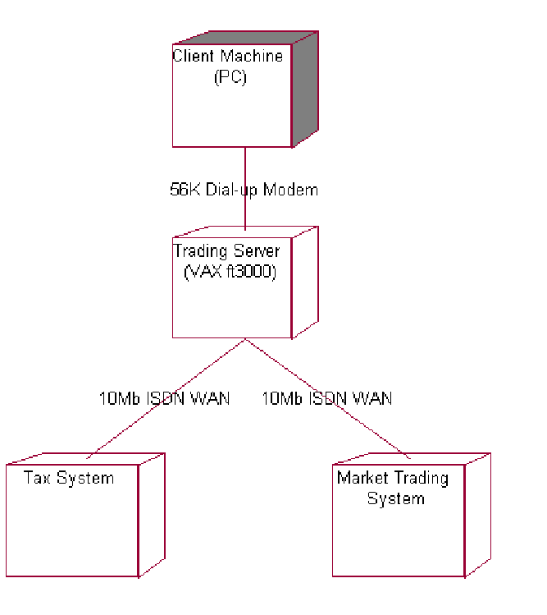
练习4.2描述问题
本练习的目的是，描述问题并描述解决方案的边界。
理解你的项目中所有的利益相关者以及付费的用户，确保你考虑到所有的影响结果的因素，包括系统维护者，开发者等。
目标：
- 确定项目中的利益相关者
- 确定与系统相关的参与者
- 使用标准的问题描述格式来为项目形成问题的声明。
Part 1: Identify Stakeholders (Section 3.2 of the Vision document)
Using the Vision document included in your student pack, complete Section 3.2:
Stakeholder Summary:
Who are the key stakeholders for the class problem?
Who are the stakeholders that will actually be using the system (potential actors)?
Which stakeholders will you seek to obtain requirements from? For the stakeholders that are not sources of requirements, what should you do with them?
All users of the system are stakeholders because they are materially affected by the system. But there are some stakeholders (for example, stockholders) who are probably not actors because they will never use the system.
Part 2: Identify Actors and Boundaries
An actor is a user of the system. A user can either be an individual or an external system. By definition, an actor is outside of the system, therefore; identifying the actors helps to define the boundaries of the system.
Label some of the actors in the diagram below. Use the following questions to help you determine if you have found them all. Refer back to the business background in Exercise 4.1 to help you identify your initial list of actors.
Actors
• Who uses the system?
• Who gets information from the system?
• Who provides information to the system?
• Where in the organization is the system used?
• Who supports and maintains the system?
• What other systems use this system?
Boundaries
• What are the interfaces to outside systems for our project?
• How can use cases help us figure out these boundaries?
• What is part of the system?
• What is not part of the system?
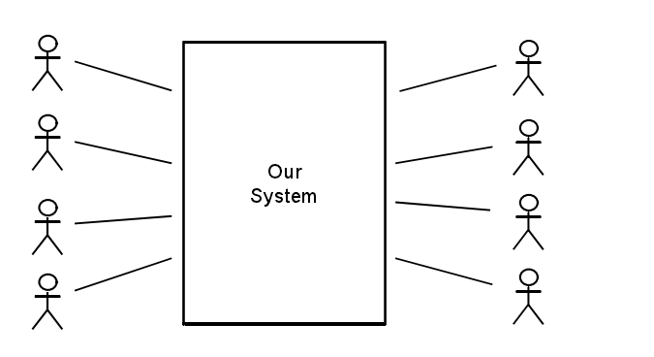
Part 3: Identify Constraints (Section 6 of the Vision document)
Complete Section 6: Constraints of the Vision document.
What types of constraints might you encounter in your class project?
Part 4: Problem Statement (Section 2.2 of the Vision)
Complete Section 2.2: Problem Statement of the Vision document.
The problem statement table is a tool for gaining agreement on the problem being solved. This is a simple technique to help articulate the problem and to ensure that everyone agrees on the problem. Fill in the problem statement table for your class project.
Below is a copy of the template and an example to help you get started.
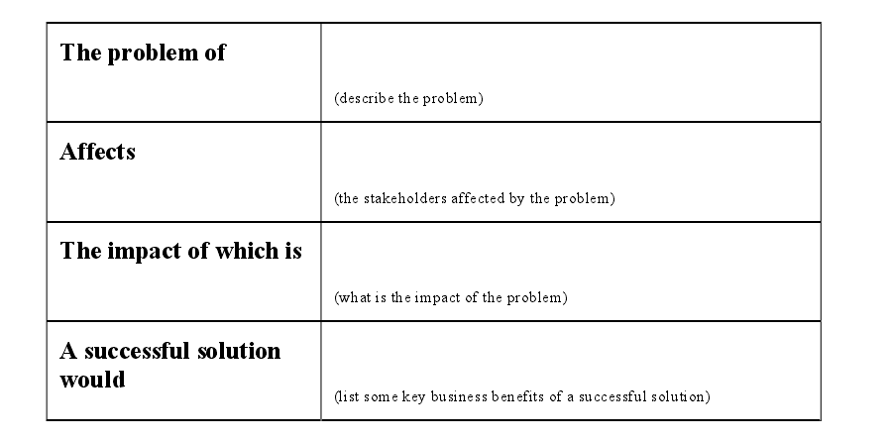
4.实验步骤：
- 根据问题目标、业务背景、问题陈述（描述）等，确定系统的参与者Actor（用户），确定系统相关功能用例Usecase，做出用例图。
- 使用鱼骨图去查找问题发生的根源。

实验三 需求文档
1.实验目的
- 掌握需求开发中从业务需求、用户需求到功能性和非功能性需求的逐步细化的需求获取技术和方法；
- 掌握需求规格说明书(SRS)的编写；
- 掌握对系统最终的需求用需求规格说明文档进行描述的方法；
2.预习与实验要求
- 预习实验指导书及教材的有关内容，了解需求规格说明文档的编写规范及模板；
- 掌握需求规则说明文档的内容，掌握需求细化，逐步分析获取的方法；并能把细化分析的需求编写到规格说明文档中；
- 实验前认真听讲，服从安排，尽可能独立思考并完成实验。
3.实验原理
- 软件需求规格说明，需求标识；
- 需求细化分析的方法及完善模型的技术；
- 软件需求规格说明模板；
- 编写需求文档的原则；
4. 实验内容
1.检查并改进用户需求规格说明书
本练习中，从系统需求中确定并逐项记录需求，这是在线股票交易系统的系统需求规格说明书。练习的目的是，为了使学生能够熟悉传统格式的需求文档，并逐渐能够确定派生的需求。
In this exercise, you do the following tasks:
Review the Online Stock Trading System Specifications.
Look for possible requirements.
Mark and number each requirement.
Refine the solution boundary by revisiting the list of actors.
Review a sample list of stakeholder requests.
Update the Vision with the stakeholder needs you have identified. (optional)
练习目标：
      - 检查在线股票交易系统的规格说明书（P27）。
      - 查找其他可能的需求。
      - 标记并为需求进行计数。
      - 通过重新访问参与者的列表来提炼解决方案的边界。
      - 回顾利益相关者请求的示例列表。
      - 改进该需求规格说明书。
第一部分 （分组完成）
- 找到在线股票交易系统的初始需求（注意该需求是不完整的）
- 读一遍需求规格说明书（P27）。
- 标记任何你认为是软件需求的部分。
- 改进该软件需求规格说明书。
第二部分（分组讨论）
- 列出所有你找到的需求
- 比较不同成员找到的需求的数量的差异。
- 集体讨论。讨论的问题包括：
为什么会有数量的差异？如何处理这些差异？
标准化文档的好处有哪些？需求的鉴定方法有哪些？
当你从用户那里获取到一个需求时，你怎样处理？
你的参与者列表是否发生变化？
Part 2: ReIn this exercise, familiarize yourself with the list of sample stakeholder requests. This list is used to illustrate traceability in subsequent exercises.
Note: The following is a sample list of stakeholder requests that were produced during the workflow detail of Understand Stakeholder Needs. This list is included so that the traceability from stakeholder requests to features and use cases can be illustrated. The list is not intended to be exhaustive and there any many other stakeholder requests that you may have elicited.
1. Review the list of sample stakeholder requests. (This is used as input into the next exercise.)
2. List the needs in section 3.7 of your Vision document (Optional).
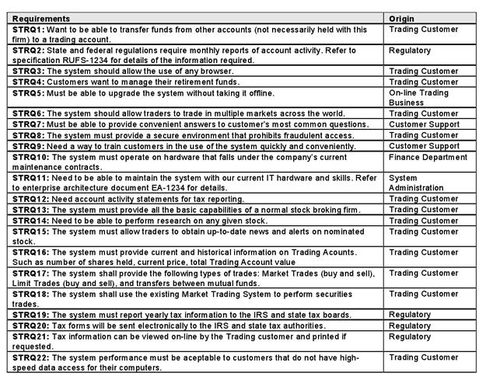
Brainstorming
• Try brainstorming as a requirements elicitation technique.
• Update the Vision document with the needs you identify.
As project lead, you need to identify the needs of the stakeholders for your new system. You have called your stakeholders together for a brainstorming session.
Remember: The needs you identify must help solve the business problem. If they do not, why have them?
To do this exercise, put yourself in the shoes of the stakeholders. Consider what they need from the system.
All stakeholders have all been trained on the rules of brainstorming:
• Clearly state the objective of the session.
• Generate as many ideas as possible.
• Criticism and debate are not allowed.
• Change and combine ideas.
2.确定系统特征
1）本练习中，更新描述文档；在股票交易系统的案例中，讨论系统特征，并写出一个职位的声明，在项目中列出所有的特征。
As project lead, you are responsible for the Vision document for your project. Your team has been working to describe the problem and how to address it, identify stakeholders and users, elicit stakeholder/user needs, identify key product features, and recognize constraints. Now, formalize this information in your Vision document.
分组讨论（问题的描述；利益相关者和参与者；鱼骨图；关键利益相关者和用户需求；约束条件）
讨论一些产品特征：查看利益相关者的请求；对于每个请求，确定一些你打算包含在系统描述中的关键特征；给每个特征一个需求标签；
Things To Consider
• Are there any stakeholder requests that do not trace to one or more features? What should you do in this situation?
• How does the Product Position Statement differ from the Problem Statement? Why is it useful to have both of them in your Vision document?
• How does viewing the results of putting together a Vision document influence your perception of your project?
写出一个产品职位清单
The product position statement is a tool for communicating the intent of the application and the importance of the project to all concerned personnel.
Complete the product position statement table for your class project. Refer to the Vision document for further instructions. Below is an example to help you get started.
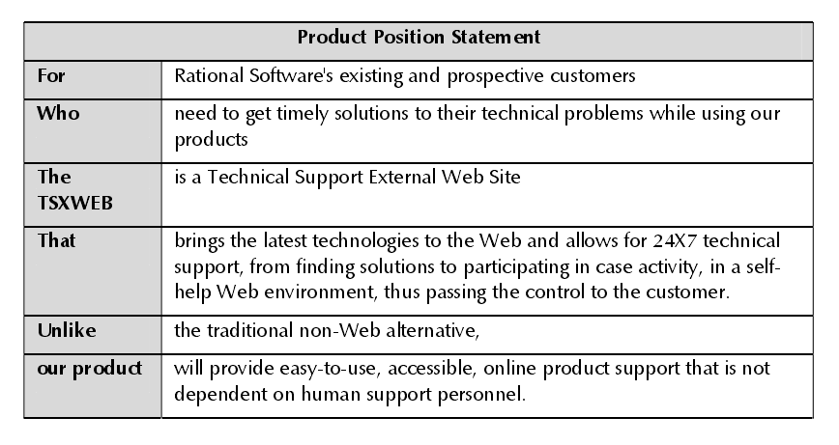
2）确定用例
确定了该项目的参与者和用例之后，请画出用例图.
In this exercise, complete the following tasks:
Identify the use cases for the system.
Create a brief description of the selected use cases.
Create a use-case diagram for the system.
作为项目负责人，你希望从用户的角度来理解该系统，了解用户期望使用该系统来完成什么。整理一下你所收集的信息，并建立需求的用例模型。在用例建模的过程中，确定用例，并为每个用例写一个简要的描述，接下来为用例建立一个详细的描述文件。当你查看系统的初始请求和其他信息时，你也许会感觉到，需求还是远远不完备的，记录下你的想法和你打算咨询客户的问题。
Identify Use Cases
What are the goals of each actor?
• What will the actor use the system for? Will the actor create, store, change, remove, or read data in the system? why?
• Will the actor need to inform the system about external events or changes?
• Will the actor need to be informed about certain occurrences in the system?
Does the system supply the business with all of the correct behavior?
Draw the Use-Case Diagram
Draw a use-case diagram for the class project.
Discussion Topics
How does your solution compare with the sample solution? What is different? What is the same?
Are the use cases too small? Should some use cases be combined?
Does the brief description provide a good overview of the use cases purpose? Is there too much detail, not enough detail, or just enough detail?
Does the diagram cover all activities? Can you think of any activities not covered?
How do you know what is done in each use case?
Does your use-case model satisfy the goals of all stakeholders?
Did you identify any new actors?
R-U est系统 需求规格说明书：
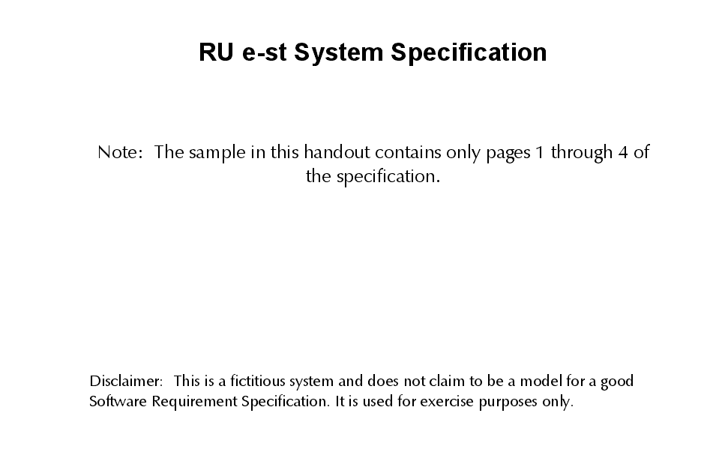
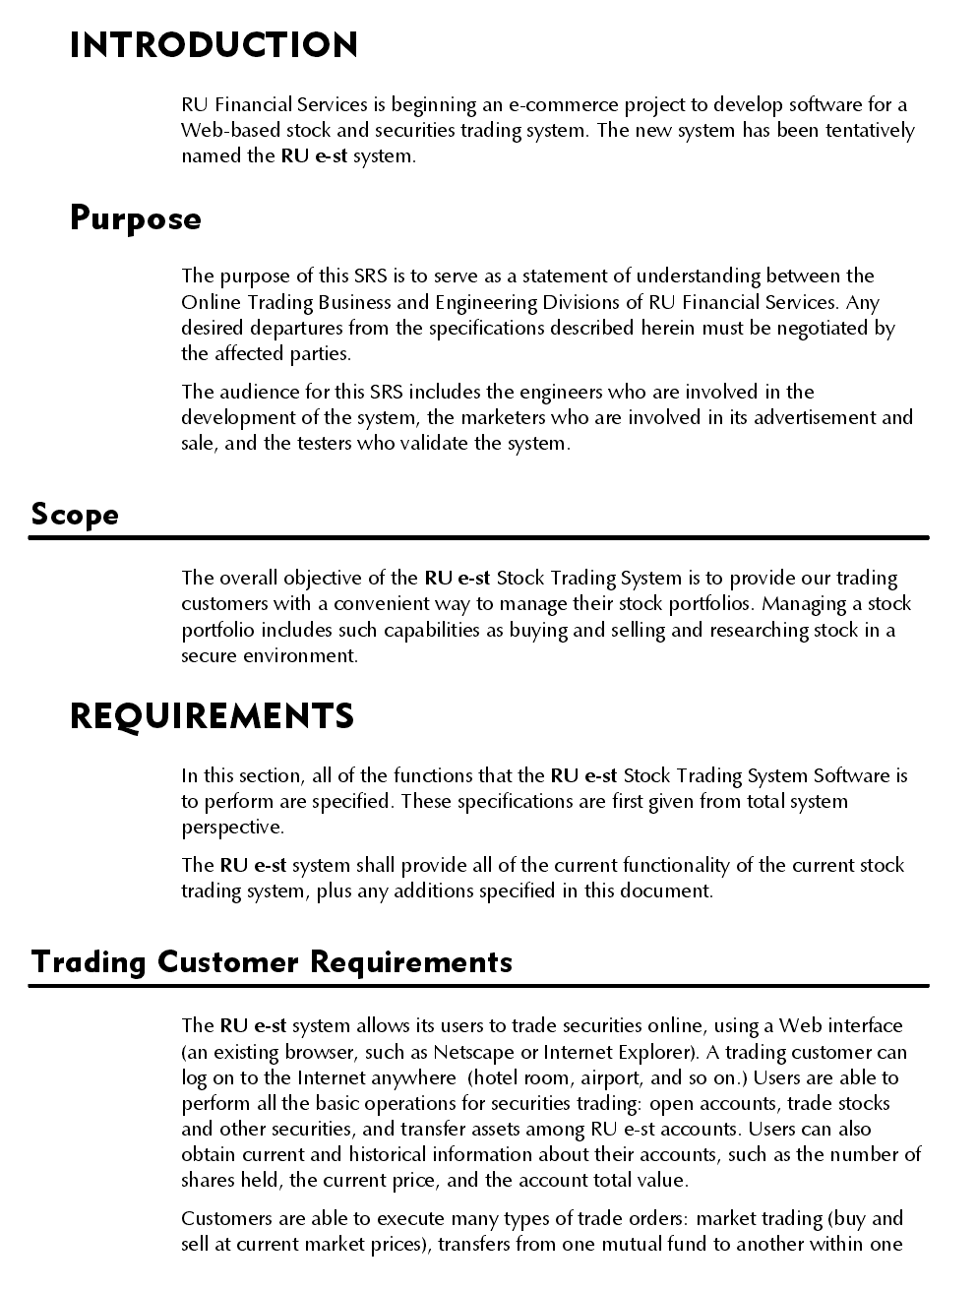
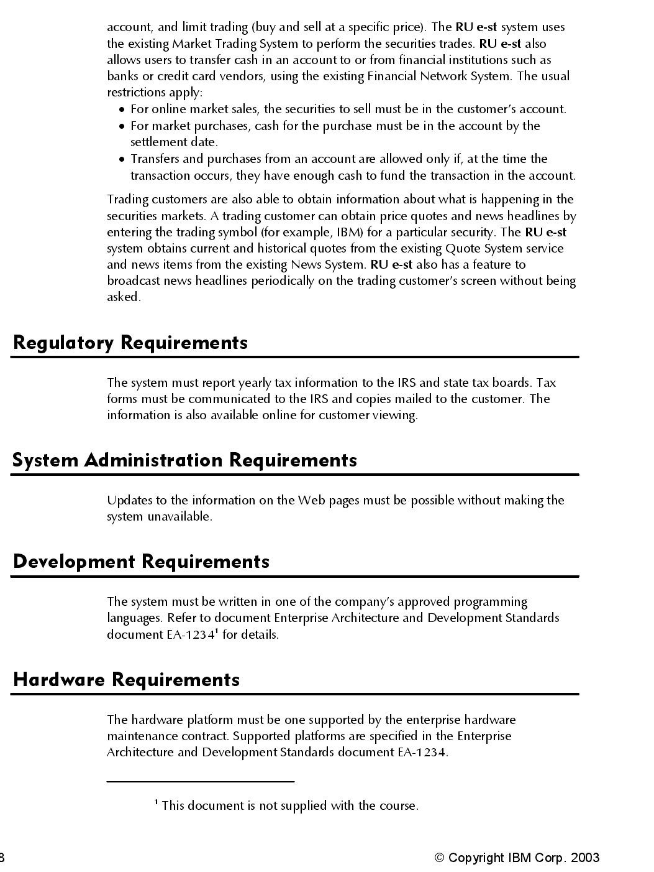

实验四 需求管理
1.实验目的：
- 通过采用项目管理或者需求管理的方法对实际项目的需求项进行管理，理解需求管理的过程，掌握需求管理的方法、工具和技能；
- 通过实验了解和掌握UML和Rataional等工具的使用方法。
- 理解软件需求风险评估和需求跟踪的常见模式和流程；
- 掌握软件需求风险和跟踪文档的编写和步骤；
2.预习要求：
- 复习所学需求管理的方法和过程；
- 预习实验步骤，了解实验中要求的注意事项。
- 掌握需求风险评估和跟踪意义和作用；
- 对需求规格文档SRS进行风险评估和高风险需求进行实时跟踪处理进展，编写跟踪矩阵文档，以及跟踪文档设定操作；
3.实验内容：
1.熟悉和掌握Project的使用。
熟悉和掌握Rational RequsitePro工具的使用。
分别在Project和RequsitePro中创建出相关的需求项列表，定义优先级别及其关联关系，并根据需求项列表进行系统规模、工作量、成本和进度的估算。
对于需求变更进行管理。
利用理论知识内容完成SRS的风险评估和跟踪矩阵的输出。
评估需求风险需要注意以下几点：
1、需求获取阶段
1) 如涉及到非功能需求，需要明确
2) 对需求基线的合理建立进行评估
3) 是否给出期望的解决办法
2、需求分析阶段
1) 划分需求优先级，优先级高的重点考虑
2) 关注可能带来技术困难的特性
3) 对不熟悉的技术、方法、语言、工具或硬件平台进行风险评估
3、需求规格说明
1) 对需求的描述和定义不能太过抽象，简单直接明了为上。
2) 对具有二义性的术语和用户特有的专业术语解释说明是否到位。
4、需求管理
1) 需求变更的处理流程和机制是否双方达成一致
需求跟踪矩阵
1、需求跟踪提供了一个与合同或说明文档相一致的方法。
2、需求跟踪通过持续跟进需求任务的进展，不限于需求分析阶段，还包括设计、开发、测试等阶段，及时发现问题，达到可以改善软件开发质量，降低维护成本
2.通过属性特征为需求进行优先级分级
1.学习如何通过需求的属性特征作出决策，决定每个需求的相关重要性。各个小组要制定一个分级制度，考虑到产品开发时需求任务处理的先后次序。
其中要考虑的属性如下：
- 需求的内容
- 从客户那里得到的优先级
- 开发的难度
- 项目风险
- 需求的稳定性
目标：
- 检查特征矩阵和属性
- 决定属性的相关重要度
- 为特征进行优先级的选取
- 决定基线
You are the Vice President of Engineering for the product. The Development Manager (the instructor) has just told you that you only have the resources to accomplish two-thirds of the work shown on the feature list. You have to catch a cab to the airport in 20 minutes, so you have no time to go back to talk with the customer. What requirements would you recommend for the baseline scope?
Work together in a small group.
1. Review the features matrix worksheet on the next page.
2. Discuss the relative importance of the attributes.
3. Rank the features based on their attributes.
• The text of the requirement
• Priority (input from the customer)
• Difficulty (input from development)
• Risk (to the project)
• Stability (of the requirement)
List the feature numbers in the order of priority on chart paper or a transparency.
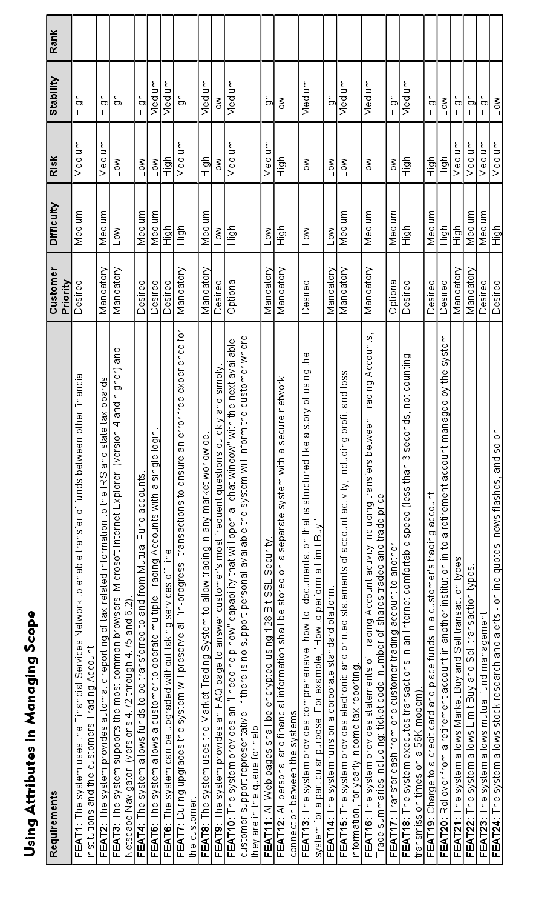
讨论下列问题：
- 你采用什么方法去获取结果？
- 使用公式的优点有哪些？
- 不同的方法和假设会导致哪些不同的结果？
- 当你要做出决策时，你还需要哪些相关信息？
制定优先级方案
The purpose of this exercise is to identify which scenarios you want to detail in this iteration. You should use your prioritized list of feature requirements to make a decision.
As a whole class, consider the ranking of each feature and describe the scenario it traces to.
In this exercise, complete the following tasks:
Review the prioritized list of features.
Trace the features into each scenario and use that to list the scenarios that you detail in the next module.
Based on the prioritized list of features from the previous exercise, list the scenarios that should be detailed and implemented in this iteration.
For the purposes of this exercise, imagine you are in the first iteration of the Construction Phase of the Rational Unified Process®. This means that all architectural risks have been mitigated and that you are now focusing on removing the risks related to not delivering system functionality that is important to the customer, as well as getting the bulk of the work done.
3 选择一种样式
查看书写事件流的样式并进行比较，每种都有自身的优点。
• Who is the reader?
This may differ from project to project. Sometimes you may have a "customer" of the system, or at other times you need to try to understand what the market wants without having a “customer.” Depending on who will be reading the flow of events, there are many different ways to write it. If the readers are unfamiliar with the system and the Rational Unified Process, you should describe it in one way. On the other hand, if the systems are well known to all readers, you may choose to describe it in another way. Regardless of the way you choose to describe it, be consistent for all use cases in your project.
• Who is the author?
It is not easy to make everyone in a project team write the flow of events in the same way. The style depends on many factors, including the skills and background of the authors. For example, if some people have problems expressing themselves, it may be easier to make a more formal template for the flow of events. Your use-case modeling guidelines can help ensure that there is a consistent style.
After you have finished detailing your flow of events, your co-worker Bob mentions that he has seen use cases written in other styles. He thinks that the team should decide what style they want to use for their use cases. He proposes some sample styles to choose from.
Review each of the following samples of a flow of events that are written in different styles. As you read each style, consider the following:
Consider the following questions when comparing the use cases:
• Is it easy to read and understand?
• Do you think it would be easy to create (write) with a word processor?
• Do you think it would be easy to maintain if you were inserting and reorganizing the flows?
• In what ways is it better than the others?
• In what ways is it worse than the others?
• Which style do you prefer?
事件流（基本事件）：
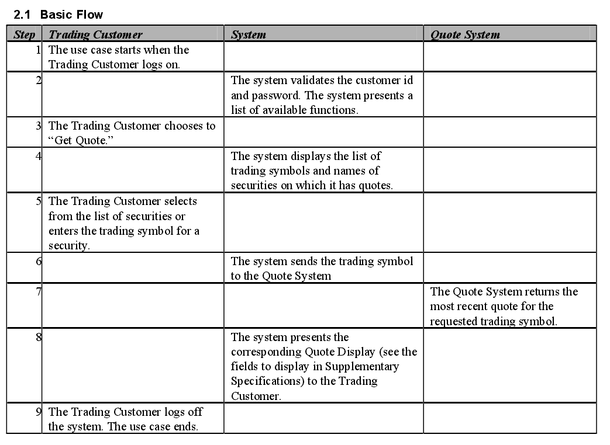
备选流：
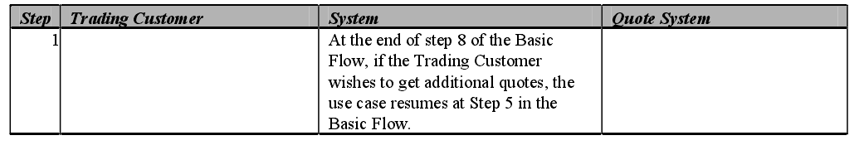
4.实验步骤：
- 在Use cases包下，创建用例项目。创建用例规格描述文档.将模型中的用例全部导入到Project中，分配每个用例的工期、开始时间和完成时间、前置任务、资源。
- 需求风险评估与跟踪。

